MACH4METAL

metalworking machinery
Transito 21, 6909 DA Babberich, Netherlands
Tel. + 31 (0)316 – 247123
Fax. + 31 (0)316 - 247956
info@mach4metal.com
www.mach4metal.com
Bank No : 66.52.13.883
IBAN : NL33 INGB 0665 2138 83
BIC : INGBNL2A
VAT : NL 815393635B01

CNC Lathe Gildemeister CTX 410

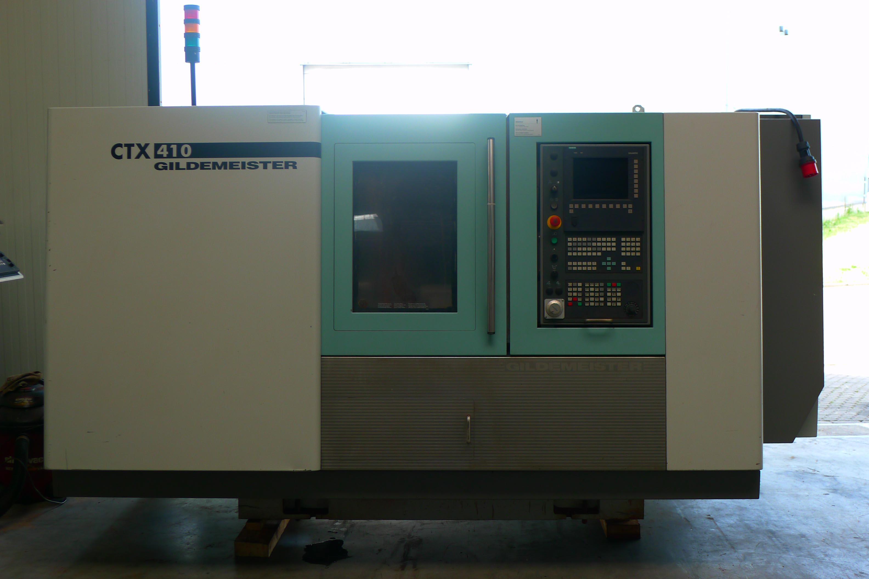
- Make : DMG Gildemeister
- Type : CTX 410
- Age : 2004
- Mach No : 013 600 01131

- Swing over bed : 505
- Swing over slide : 365
- Max. turning length : 600
- Spindle bore : 76
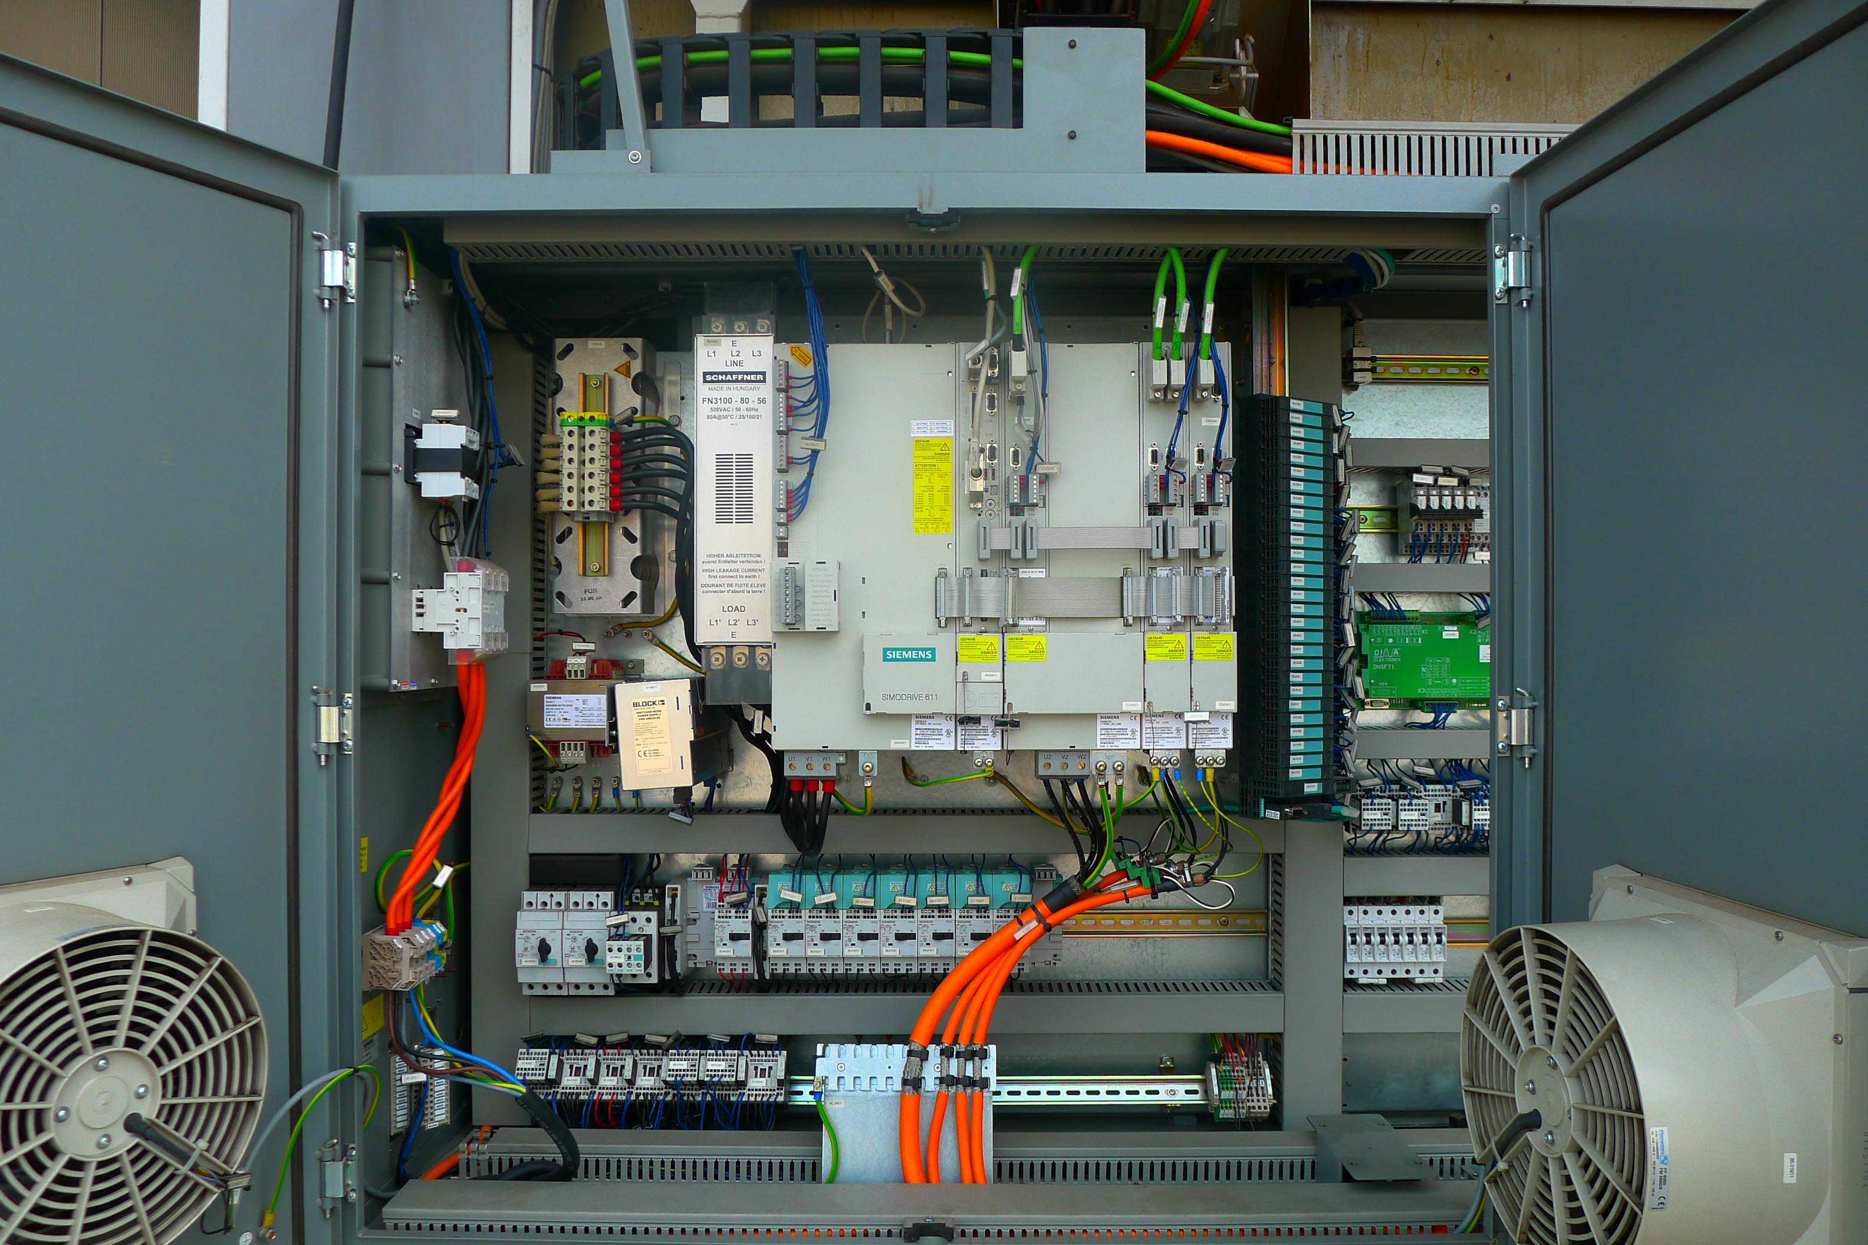
- Spindle speeds : 5.000 Rpm

- X Axis travel : 260 mm
- Z Axis travel : 635 mm

- X Axis rapid feed : 30.000 mm/min.
- Z Axis rapid feed : 24.000 mm/min.

- C axis
- 12 Position driven live tooling
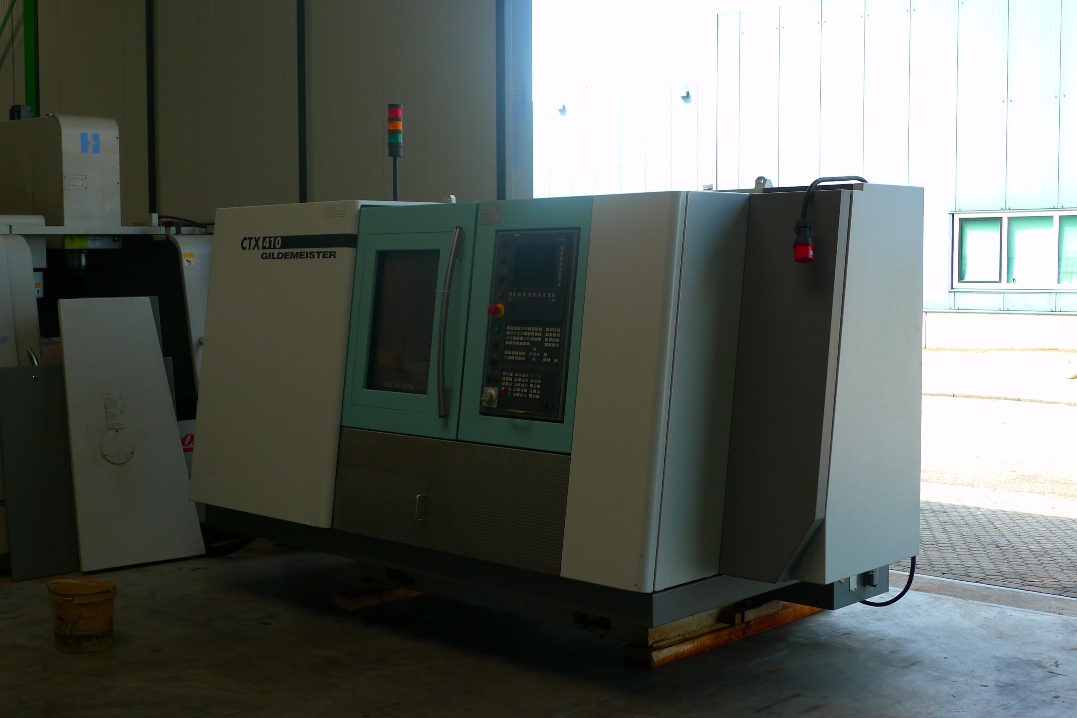
- Main power 21 kW
- Chip conveyor
- Tailstock
- Spindle bore Ø 76

- Dimensions
- Length : 3.175
- Width : 2.080
- Height : 2.000
- Weight : 5.500 Kg

- CNC SIEMENS 840 D Shopturn

Please Note: The above information has been obtained to the best of our ability and belief from, and from the manufacturers where possible. It is given in good faith, but its accuracy can not be guaranteed. Accordingly, it will not form a representation or constitute contractual terms. We advise you to check any vital details!

